LAB ASSIGNMENT-3

**ANDROID APPLICATION USING CAMERA AND**

**LOCATION**

Signup:

User can create an account by filling the details. Details contains uploading a image. The image can be chosen either from camera or gallery.

User selects image by image or gallery.

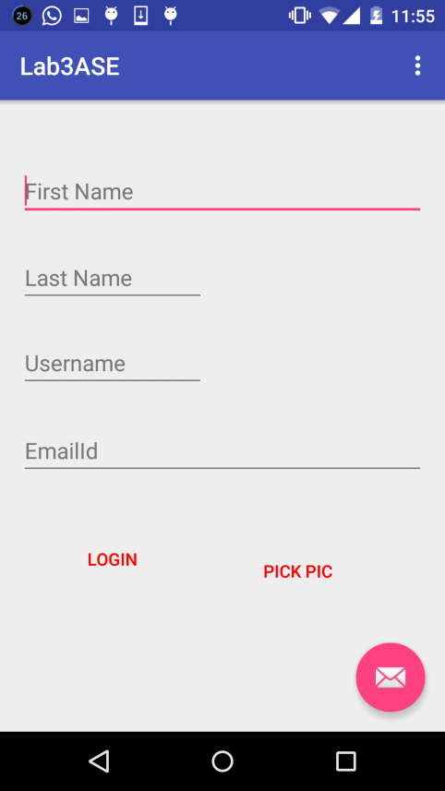

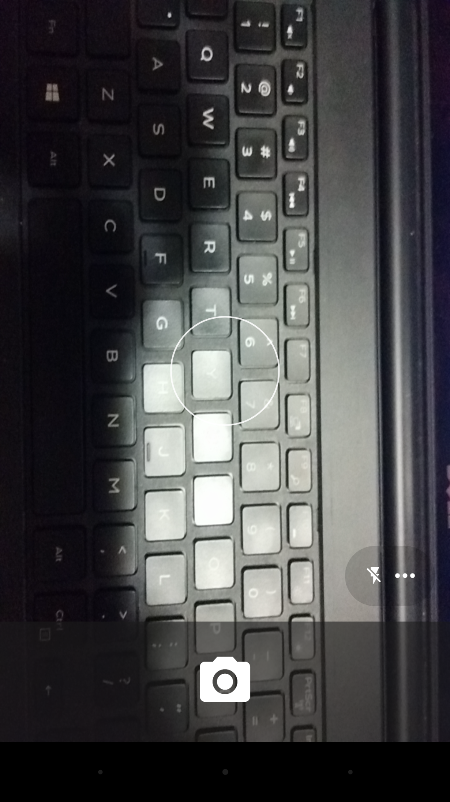

LOCATION:

User gets location in the location page. Location detected in location page is the image that is populated from signup page.

